**Car Safety:**

1. **Research Your Vehicle:**

**Maserati Ghibli 2018**

Safety score: 36.47/37

Safety Features:

Front Airbags Passenger

Seatbelt Pretensioner Driver

Seatbelt Pretensioner Passenger

Front Airbags Driver

Car Safety feature - Traction Control

Adjustable Steering Column

Front Side Curtain Airbags

Rear Side Curtain Airbags

Electronic Stability Control

Indicators

Fog lights

Brake light

Parking Light

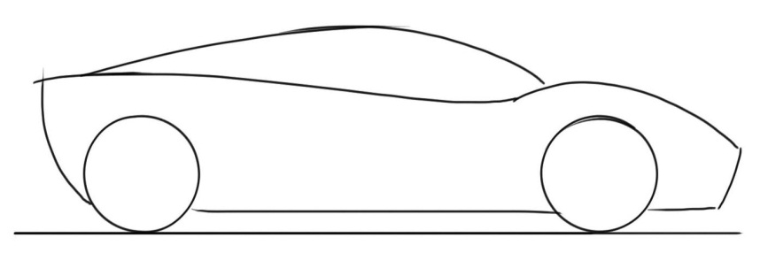

**Toyota Hilux 2006**

Safety Score: 4/5 stars

Safety Features:

Front Airbags Driver

Front Airbags Passenger

Seatbelt Pretensioner Driver

Seatbelt Pretensioner Passenger

Adjustable Steering Column

Parking light

Brake light

Fog light

Indicators

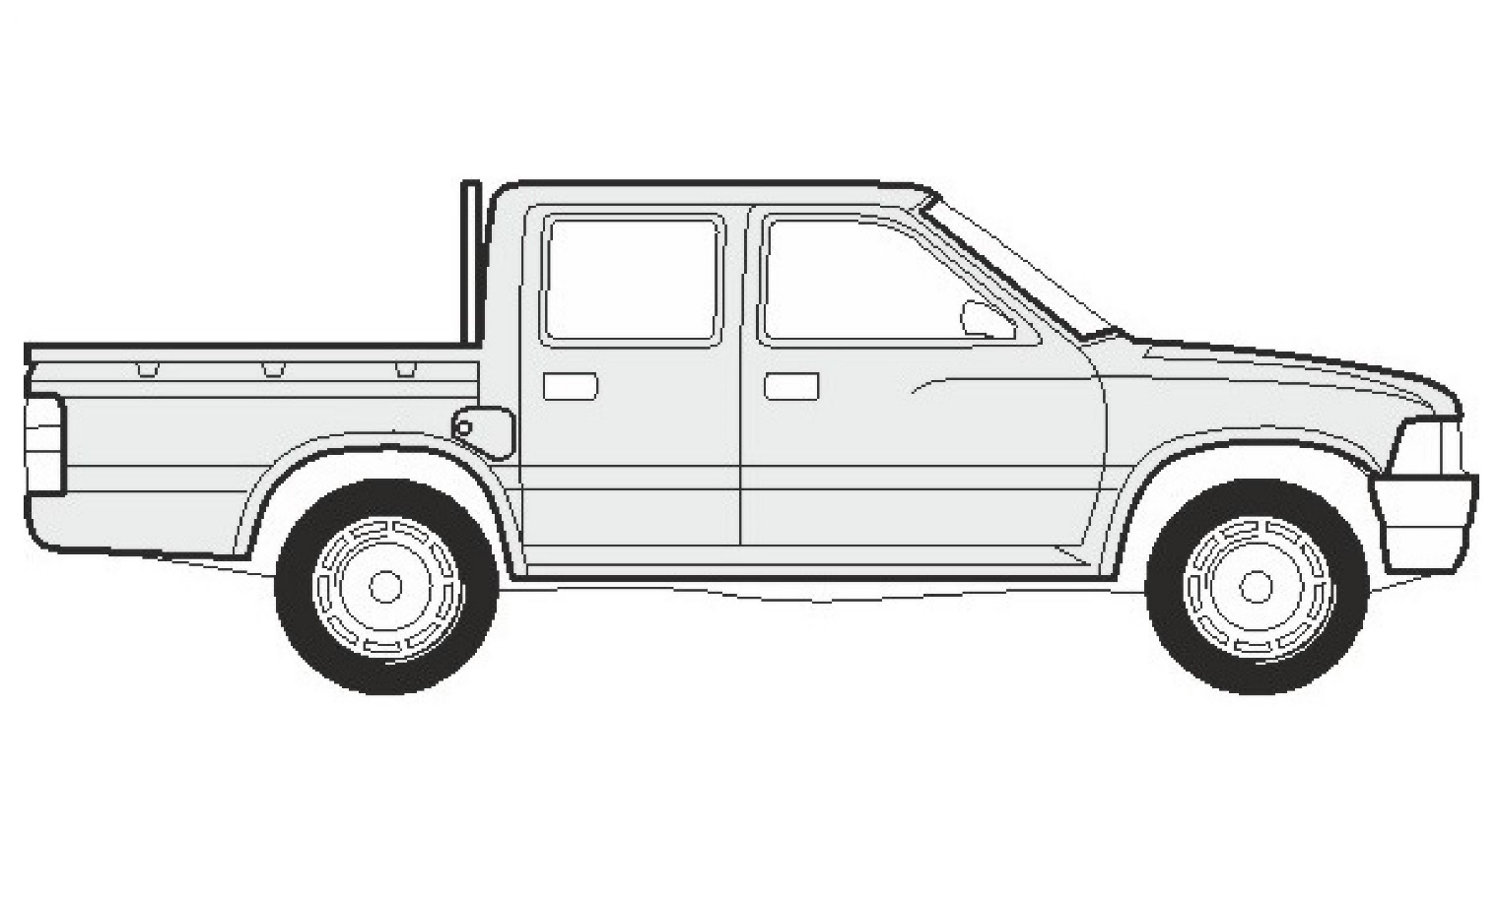

**Renault Laguna 2002**

Safety Score: 33.1/37

Front Airbags Passenger

Front Airbags driver

Adjustable steering column

Car safety feature- Traction control

Rear side curtain airbags

Front side curtain airbags

Electronic stability control.

Indicators

Fog light

Brake light

Parking light

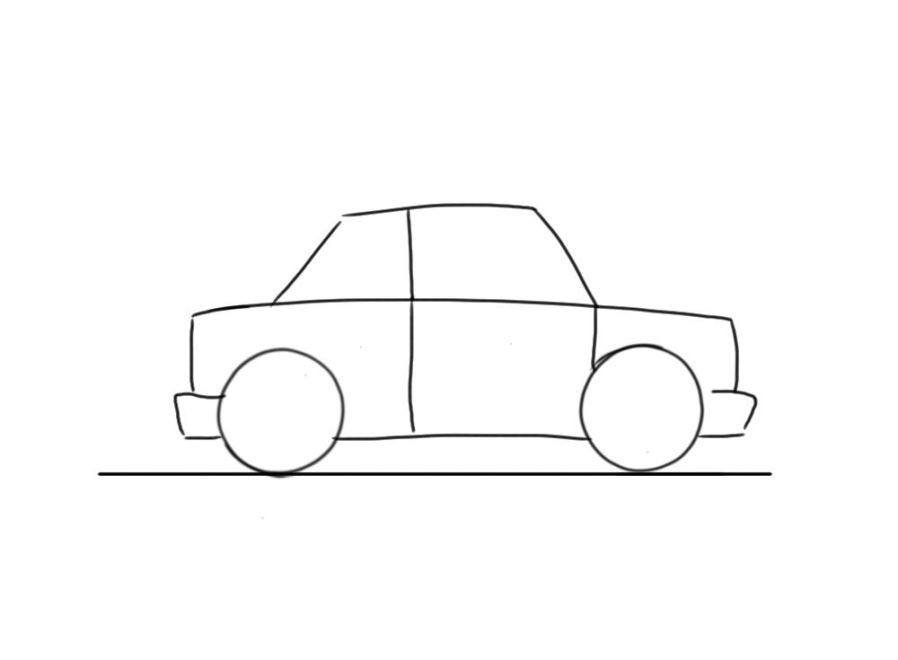

1. **Crash Avoidance Features:**

|  |  |
| --- | --- |
| **Crash Avoidance Feature:** | **How it prevents Crashes** |
| Electronic Stability Control | ESC helps drivers to avoid crashes by reducing the danger of skidding or losing control as a result of over-steering.  ESC becomes active when a driver loses control of their car. It uses computer-controlled technology to apply individual brakes and help bring the car safely, back on track, without the danger of fish-tailing. It incorporates the functions of anti-lock braking systems and traction control and is particularly effective during sudden evasive manoeuvres. |
| Auto Emergency Braking | AEB can alert the driver to an imminent crash and help them use the maximum braking capacity of the car and apply the brakes independently of the driver if the situation becomes critical. This causes there to be less acceleration in the crash and therefore less force. |
| Traction Control | Traction Control systems optimise grip and stability of the car on the road during acceleration by measuring wheel rotation. It stops wheel spin by reducing engine power or temporarily applying the brakes to that wheel, allowing the car to accelerate smoothly, even on slippery surfaces. Limited slip differentials also help provide a more even distribution of traction forces when the car is on a slippery surface. |
| Intelligent Speed Assist | ISA is a safety technology that alerts drivers when they exceed the speed limit. ISA activates when a driver exceeds the posted speed limit for a section of road by a predetermined limit (e.g. 2km/hr or more). Audio and visual warnings sound to remind the driver that they are going too fast. Which decreases the risk of getting in a crash but also if you did get in a crash the |
| Active Braking Systems | Active braking systems provide drivers with braking support during emergency situations.  There are many versions of active braking systems.  Preliminary systems assist drivers by warning them of impending collisions.  More advanced systems automatically assist drivers in preventing collisions. Like the AEB they will also decrease the acceleration, therefore decreasing the net force of the impact. |
| Handling and Stability | A car with good handling and stability gives you more control by 'holding' the road better and being more responsive. Good handling depends on the design and integration of the car's steering, suspension, braking, acceleration, body and weight distribution. Test driving different cars will give you a better idea of on-road driving characteristics. |
| Visibility | As the driver, seeing clearly around the car helps you detect risks and hazards on the road. It is equally important for other road users to see your car and know what you're doing. A [white coloured car](http://www.monash.edu/miri/research/reports/muarc263) is more visible in most driving conditions. Driving with your car's headlights always on or installing [daytime running lights](http://howsafeisyourcar.com.au/Safety-Features/Safety-Features-List/Daytime-Running-Lights/) also helps others to see your car more easily. Daytime running lights are less intense headlights that stay on during the day. Most cars can be fitted with a device that automatically activates daytime running lights when the ignition is on, but is overridden by full strength headlights, when they are needed. |

<http://howsafeisyourcar.com.au/Safety-Features/Crash-Avoidance-Features/>

1. **Crash Protection Features:**

|  |  |
| --- | --- |
| **Crash Protection Features** | **How it Protects Passengers During Collisions** |
| Crumple Zones | Modern cars protect drivers and passengers in frontal, rear and offset crashes by using crumple zones to absorb the crash force. This means that the car absorbs the impact of the crash, not the driver or passengers. |
| Strong Occupant Compartment | The increase in strength causes the car not to get crumpled as much. If it did it would cause further damage to the |
| Side Impact Protection |  |
| Seatbelts | It keeps from you flying from flying through the windshield or hurdling towards the dashboard, when a car comes to an abrupt stop, which is caused due to inertia (Newton’s first law) |
| Airbags | When a car gets hit. The inertia causes the passengers and the driver to move to a certain direction, which could cause them to hit something in the car, e.g. the dash board. Using Newton’s 3rd law when the passenger hits and air bag while it’s still inflating, it will absorb the force from the passenger, the reaction force ( the airbag) will push the passenger back at the same speed the airbag was accelerating. This causes 0 net force acting towards the head. |
| Head rests | It supports your head from being whiplashed backwards. When a car hits you from the back, your head wants to keep its initial position (inertia) this causes you head to turn back. By placing these head rests, the reaction force of it (newtons 3rd law) holds you head in place due to it being equal. Therefore, causing you acceleration to be 0 and getting no whiplash. |

<http://howsafeisyourcar.com.au/Safety-Features/Crash-Protection-Features/>